AEPHY2024
Narrogin SHS Year 11 ATAR PHYSICS Name: Solutions
Task No: | 1b
Task Type: | Science Inquiry: Experiment Validation
Content: | Heating Processes
Task Description:  Time Allowed | Validation Test  Reading time: 5 minutes  Working time: 45 minutes
Weighting: | 4%
Materials required | Physics Data Sheet, pens, pencils (including coloured), sharpener, correction fluid, eraser, ruler, highlighters, scientific calculator

Question 1 (5 marks)

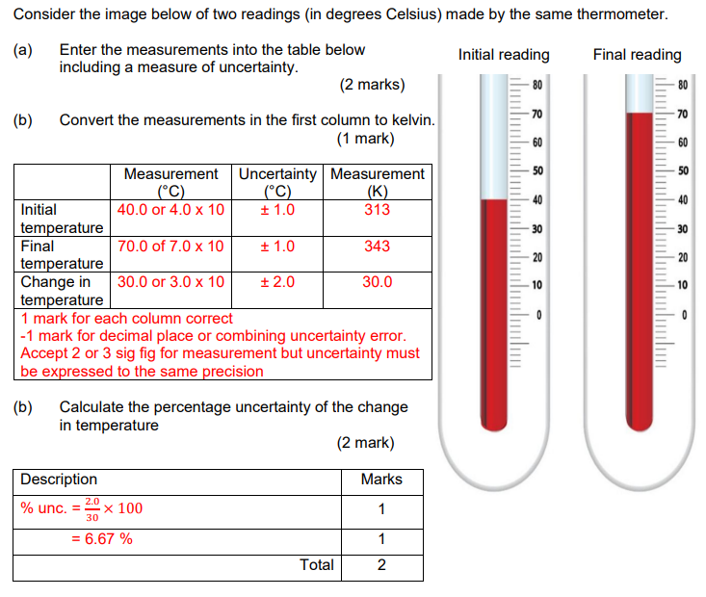

Question 2 (5 marks)

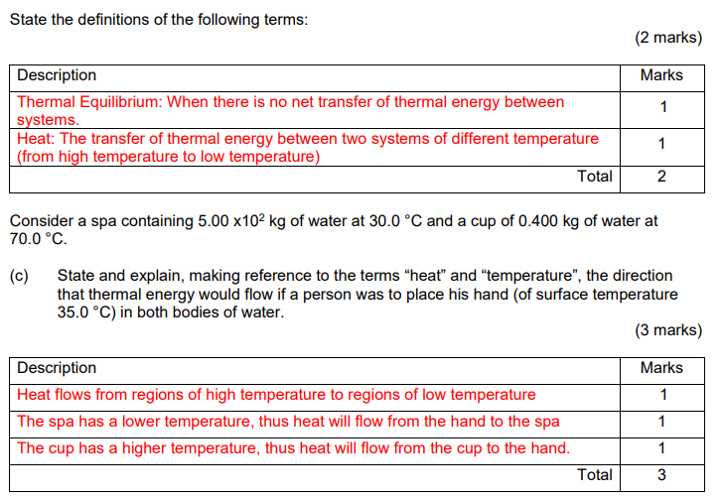

Question 3 (5 marks)

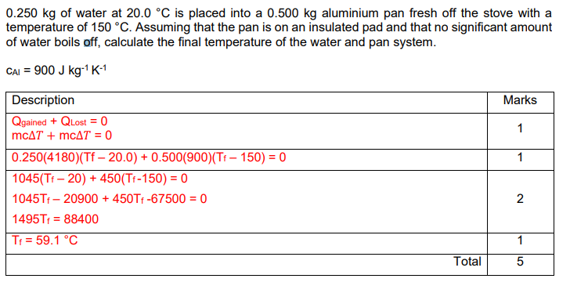

Question 4 (7 marks)

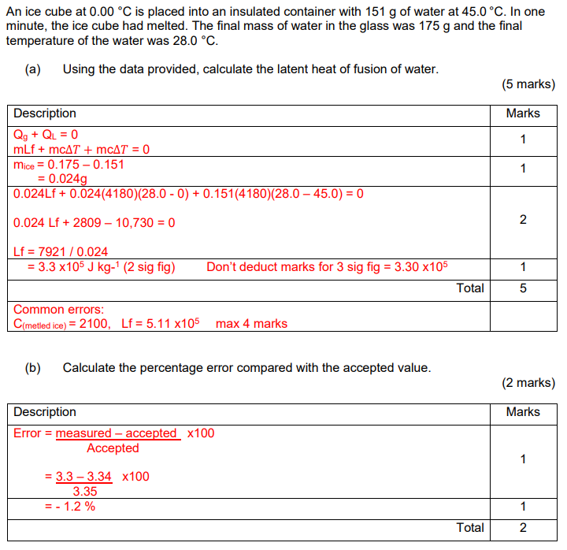

Question 5 (9 marks)

